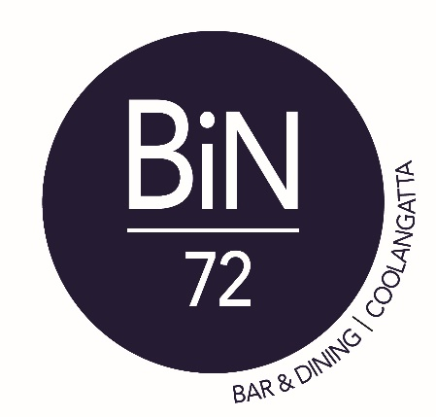

Valentine’s Day Menu
(All dishes are designed to be shared and
will be served throughout your dining experience)

Edamame (v, gf)
Mushroom & mozzarella arancini, truffle mayonnaise (v)
Grilled squid, tomato, onion, parsley, rocket, lemon dressing
Sticky soy pork belly, mustard apple pickle
Braised beef cheek over gnocchi,
sautéed mushrooms, truffle cream sauce

Dessert
Vanilla cheesecake, raspberry coulis, raspberry foam (v)

$45 per person

Valentine’s Day Vegetarian Menu
(All dishes are designed to be shared and
will be served throughout your dining experience)

Edamame
Mushroom & mozzarella arancini, truffle mayonnaise
Fried tofu salad
Baked eggplant miso, sesame, parmesan
Wild mushroom gnocchi, truffle cream sauce

Dessert
Vanilla cheesecake, raspberry coulis, raspberry foam

$45 per person

